BIOC 455
Lecture # 13– Voltage Gated Ion Channels
Lecturer: Dr. Tak Pan Wong – February 3rd, 2007

NOTE: This NTC is meant to be used as a study aid to supplement your own class notes. Hence, not all of the text or diagrams contained in the lecture slides will be reproduced here.

Please send any comments or questions about NTCs to either Wanda or James through e-mail at u3.represent@gmail.com .

This lecture will cover background information of, methods for studying, molecular structure of and diseases linked to voltage-gated ion channels (channelopathies)

The generation of an action potential (AP) is analogous to a light bulb:
- both require an electrical signal to generate an effect, but for a light bulb this electricity comes from a circuit driven by a battery.
- A neuron generates and propagates an action potential based on changes in the properties of cell membrane leading to changes in membrane potential

Action Potential
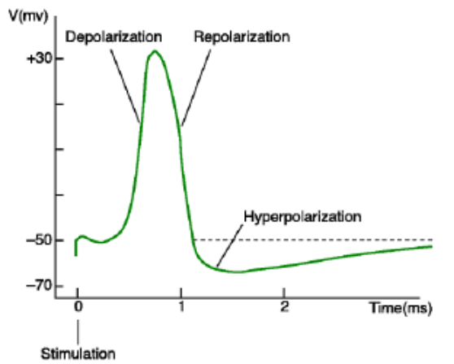
- Originally studied in the axon of giant squid neurons due to the very wide diameter of these axons (~1mm)
- In the 1950’s, Hodgkins and Huxley devised a method to measure the membrane potential of a neuron using pipettes and then developed the model for the excitable neuron
  - They discovered that an action potential can be triggered and contains three phases:
  - depolarization (going from the negative resting potential to a positive potential),
  - repolarization (quickly the membrane corrects the imbalance and overshoots creating a more negative potential than at rest)
  - hyperpolarization (the overshot phase)
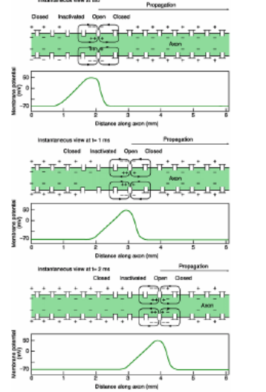
Properties of Action Potentials (all are conferred by the properties of voltage-gated ion channels in the neuronal cell membranes)
- Triggered by depolarization
- All or none (threshold)
  - There exists a threshold potential, that if crossed will trigger a full action potential and there is no partial potential – the full AP is either triggered or not, with no intermediate intensity. For each ion channel opening always get same amount of current, but for different times
- Refractory Period
  - For a certain period of time after the triggering of an AP, another can not be triggered.
  - This is due to the inactivation phase of channels.
- AP are propagated in a directional manner (speed varies from 1-100 m/s) see previous figure.
- Because of inactivation, AP can only be transmitted in one direction

Polarized membrane
- In every cell of all living organisms, there is a difference in concentrations of charged ions between the extracellular and intracellular space because the plasma membrane is made from phospholipids which are impermeable to polar/charged substances.
  - For example, Sodium is in high concentration extracellularly and low concentration intracellularly
- Voltage-gated ion channels exist to facilitate transport of charged molecules across the membrane.
  - These channels are opened by a sufficient change in membrane potential.

Voltage-gated Ion Channels
- a very large family – these constitute approximately 1.3% of the entire genome (~400 genes). Having such a large variety of ion channels allows for careful control of various ion flux.
- The majority of these channels allow passage for sodium, potassium, chloride or calcium
- Each type of channel is selective for mainly one ion species
  - Sodium channels come in over 10 different types
  - Calcium channels come in over 10 different types
  - Potassium channels come in over 30 different types
  - Chloride channels come in over 10 different types
- Not all ion channels are voltage-gated, could be ligand gated for example. Cyclic nucleotide-modulated channels, transient receptor potential channels (TRP) and voltage-gated proton channels are examples of understudied vg channels.

Functions:
- generation and propagation of action potentials
- release of neurotransmitters from pre-synaptic terminals requires opening of vg channels
- repolarization of membrane
- integration of synaptic potential
- activation of second-messenger system
  - Calcium is very important for this as well as being a second messenger itself
Different patterns/frequency of action potentials are found in different parts of the brain – localized control of voltage-gated channel opening. The frequency of AP defines passage of information in the brain, not the intensity.

Methods for Studying Ion Channel Activity
Vm (membrane potential) = Vi (potential found inside the cell) – Vo (potential found outside the cell)
Sharp electrode recording of Vm:
- By inserting an electrode into the cell and measuring the potential inside the cell, then comparing this to the outside potential, Vm is easily calculated.
  - The opening of voltage-gated ion channels changes the Vi and Vo because of the influx of ions into the cell, and this can be measured to indirectly determine the change in Vm.

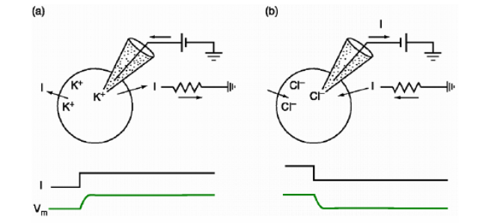

Current clamp recording:
Involves a circuit which allows for the injection of current into the cell to either depolarize or hyperpolarize the cell as well as measuring the Vm and thus channel function.
- The amount of current is clamped. We can control the amount of current.
- Injection of a positive current (a) will expel K+ into the cell and you are decreasing the negativity inside the cell = depolarizing effect to trigger an AP
- Injection of a negative current (b) will expel Cl- ions into the cell and you are increasing the negativity inside the cell = hyperpolarizing effect

Limitations:
- This is an indirect method to measure channel function because instead of measuring the ion flow through a channel, the change in membrane potential is being measured.
- By current clamp, the membrane potential can not be held constant because the functional properties of voltage-gated ion channels are affected by changes in membrane potential and thus channels will respond when current is injected. This prevents the study of channel properties in a steady-state.

Voltage clamp recording:
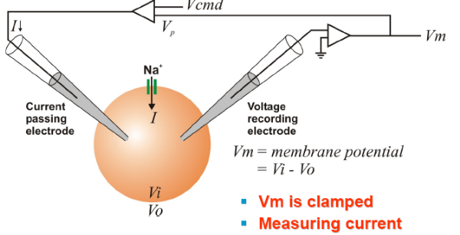
- An improvement on current clamp
- Involves both an electrode to measure voltage and membrane potential, as well as an electrode which controls the injection of current and fixes the membrane potential.
  - Monitor the membrane potential continuously and any changes can be neutralized by the injection of current.
    - For example, to hold the potential at a depolarizing -20mV requires constant injection of positive current since channels will open in an attempt to repolarize the cell.
  - More direct measurement of current because we know how much current we are injecting to neutralize the cell’s effect and thus, conversely, know the amount of current passing through voltage-gated ion channels.
- Do not need to worry about impact of potential channels on the functional properties of the vg channels, but we are measuring current not potential.

Types of Current:
- Note that the current is defined by the direction of positive ions.
- Inward Current – Depolarizing and excitatory because flow of positive ions inward drives the potential closer to the more positive threshold potential
  - Examples: Sodium and Calcium flux into the cell
- Outward Current – Hyperpolarizing and inhibitory because the flow of positive ions out of the cell increases negativity of the membrane potential and further from the threshold.
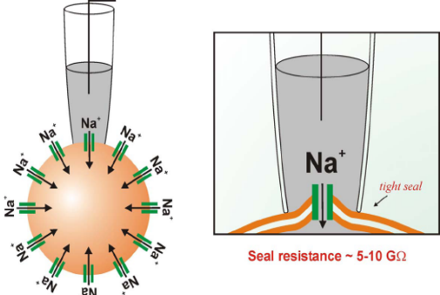
  - Examples: Potassium flux out of the cell OR Chloride flux INTO the cell (because increase negativity in the cell – for negative ions think backwards)

Patch clamp recording:
- For the measurement of the activity one single ion channel
- A pipette (tip’s diameter ~1 micron) does not puncture the membrane, but rather, with a slight vacuum pressure, forms a tight seal with the membrane which blocks out all outside noise (i.e. electrical interference from surrounding ion channels).
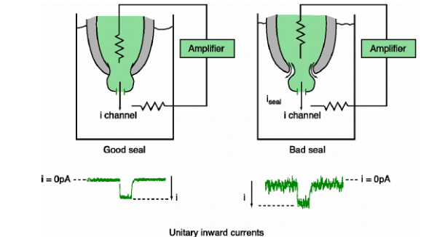
Advantages:
  - High resolution – measure activity from a single ion channel
  - Low signal to noise ratio due to the tight seal
    - A bad seal will allow for current to leak from the seal and you will see noise
  - Flexibility
    - Patch clamp can be performed in many different ways
      - Can remove a piece of membrane and perform “inside-out” studies (inside of membrane remains in the pipette) or “outside-out” studies.

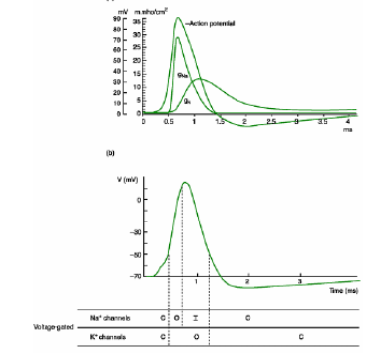
A patch clamp recording of Na+ channels will show that the amplitude of the signal is always the same, but the length of time which the channel opens is always different, because the intensity of the amount of ions that passes through is the same.
For sodium channels: 2 critical properties related to their activation:
  - Fast activation phase – depolarization yields an almost simultaneous (w/in 1 ms) activation of all sodium channels
  - Inactivate phase – after continuous depolarization, the sodium channel enters an extra tight conformation, which still leaks a little. This leakage combined with the fast activation explains the depolarizing all-or-nothing properties of the channels.

Drugs/toxins for studying voltage-gated ion channels:
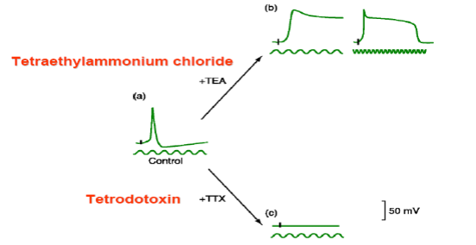
- TTX, from pufferfish, blocks sodium channels
- α- and β-toxin, from scorpions, block sodium channels
- μ-conotoxin, from cone snails, block sodium channels
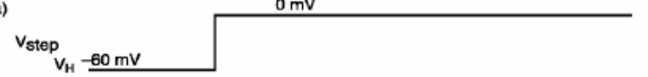
- flat line and 0mV Vm, shown below, because cell can not be depolarized

- ω-conotoxin, from cone snails, block N-type Calcium channels

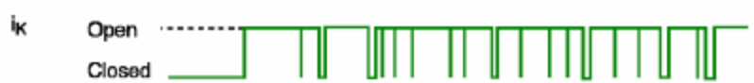
- TEA blocks potassium channels – the cell still depolarizes, but remains depolarized because you have removed its ability to repolarize.
- Shk-toxin, from sea anemones, block potassium channels

- Potassium channels remain open almost constitutively, there is almost no inactivation with the addition of TEA or Shk-toxin – potassium channel has a slow inactivation. Also you can see that there is generation of a lot of outward current.
  - Potassium channels have a slow activation and will thus open after the opening of sodium channels to provide a delayed rectifying outward, hyperpolarizing current for repolarizing the cell back to resting membrane potential.

Molecular Structure of a Sodium Channel:
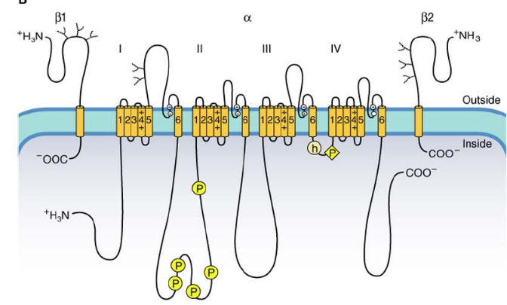
- 4 repeats of 6 transmembrane segments (S1-S6 domains – these are alpha helixes)
- α subunit: most important subunit for ion channels, functional unit of a voltage-gated channel, which contains the pore for ion passage, voltage sensor and binding sites for specific toxin (e.g. tetrodotoxin for vg sodium channel)
- β subunit: mainly for modulatory roles
- S4 – the voltage sensor, contains positively charged amino acids that serves as a sensor for membrane depolarization and then induce a conformational change when suitable.
- Long linking region S5 and S6 form the core of the ion channel and also determine the identity (which ion can pass) of the ion channel
- Region between repeats III and IV meadiates inactivation of sodium channel.
  - The mutation of three amino acids in this region (IFM – isoleucine, phenylalanine and methionine) to glutamine abolishes a channels’ ability to inactivate; this proves the importance of this region in inactivation.
- Functioning of the ion channel can be modulated by intracellular signals, such as phosphorylation.
This molecular plan is what is used to determine if a protein fits the criteria to be an ion channel.

Potassium Channel:
- requires the association of 4 separate subunits, whereas for sodium these are all linked together. The rest is the same.
- Some potassium channels are not voltage gated such Ic which is triggered by an influx of calcium. Some are also activated by acetylcholine

Calcium Channel:
- Have additional regulatory subunits.
- Two major types:
  - Low threshold – activated in response to slight depolarization
  - High threshold – activated in response to strong depolarization

I_{h} – Hyperpolarizing Activated Current:
- Some channels exist which are only activated in response to hyperpolarization of the cell.
- Not ion selective (permeable to sodium and potassium)
- Mostly important for pacemaker cells, like myocytes and some neurons, which generate their own rhythmic cycle of depolarization and repolarization. This allows for autonomous activation.
- Mediated by calcium channels.

Channelopathies:
- mutations of ion channels
- Epilepsy
  - Due to uncontrolled firing of a large group of neurons. Many cells become activated at once because o
  - Some people contain a mutation in PCN2 – a voltage gated potassium channel responsive to muscarine (aka Acetylcholine).
  - The neurons containing this mutated channel are 30% more active than wild-type neurons. The channel doesn’t allow for repolarization because the flow of potassium is blocked.
- Anticonvulsant Drugs
  - Many of these are ion channel blockers, so as to slow down the activity of the overactive neurons.
    - Phytoin – prolongs sodium channel inactivation
    - Valproate – sodium channel blocker
    - Ethosuxamide – blocks T-type calcium channels

For those who want to get additional info on voltage-gated channels:
- Principles of Neuroscience (2000) 4th Ed. Kandel et al. Chapter 9
- Fundamental of Neurosciences (2002) 2nd Ed.Squire et al. Chapter 6
- Basic Neurochemistry (1999) 6th Ed. Siegel et al. Chapter 6
Additional info:
- Cellular and Molecular Neurobiology (2001) 2nd Ed. Hammond et al. Chapter 5

